Chapter 10

What Do We Know and Do Not Know?:

Attitudes Toward North Korea and Unification

Jaeyoung Hur (Yonsei University)

Sanghoon Park (University of South Carolina)

Abstract

This article examines whether existing explanations of South Korean attitudes regarding North Korea and Korean unification adequately explain changes after the declaration at Panmunjom on April 27, 2018. This study uses the National Consciousness Survey Data to estimate these shifts in attitude. Our results show that South Korean attitudes shifted following the Panmunjom Declaration for Peace, Prosperity, and Unification of the Korean Peninsula. We show that existing explanations for generational effects do not explain the national attitude shifts on unification; our study demonstrates that a wide divergence exists between younger and the older generations, and younger generations are more likely to display a negative attitude toward North Korea and unification even after the Declaration. We also show that the prospects of unification evoke different attitudes across generations. Our results imply that the Panmunjom Declaration is a prominent political event, but it is necessary to analyze it without overestimating it.

Keywords: The Panmunjom Declaration, Attitudes on Korean Unification, Attitudes toward North Korea, Generations, Prospects of unification

# Introduction

The unification policy in South Korea has been up and down with various handovers of administration. Conservative administrations tended to take a strong stance against North Korea, while liberal administrations led the engagement policy as a basis for reconciliation and cooperation. President Jae-In Moon, elected in a shift of power from the conservative administration over the past decade, is leading the inter-Korean relationship to a new phase. The new administration is pushing for policies that require inter-Korean cooperation, which was not the case under the conservative administration. For instance, the inter-Korean relationship is rapidly changing in political, cultural, and military policies, such as the joint inter-Korean rail investigation, the withdrawal of the demilitarized zone guard post (DMZ GP), the linkage of the arrowhead roads in DMZ for the KIA (Killed in Action) Recovery and Identification project, and the promotion of forest cooperation.

Indeed, the inter-Korean relationship faced several historical events in 2018. North Korea sent athletes, cheering squads, and art troupes to the Pyeongchang Winter Olympics. After alleviating these tensions and creating an atmosphere of cooperation, South Korea and North Korea held three summit meetings together. The series of meetings led to the Panmunjom Declaration on April 27, and the Pyongyang Joint Declaration on September 19. Similarly, incumbent leaders of the United States and North Korea held their first summit in history. At the first meeting, between the US and North Korea, the leaders adopted the Singapore Joint Statement, promising a joint effort to build a lasting and substantial peace regime on the Korean peninsula. US– North Korea relations, as well as inter-Korean relations, are on a new path, and we are in a unique international situation concerning the Korean Peninsula.

The Panmunjom Declaration reminds us of the 10.4 Inter-Korean Joint Declaration in 2007, which made South Koreans expect that it is possible to solve the inter-Korean relations with reconciliation and cooperation. In particular, the Panmunjom Declaration is an effort to improve North Korea relations entirely after the 5.24 measures, which cut off relations with North Korea. The world has indeed paid attention to the Panmunjom Declaration, and the Korean government has shown optimistic expectations. However, there are also criticisms that the Panmunjom

Declaration contents are not much different from the past 10.4 South-North Summit Declaration, which eventually failed to manage the inter-Korean relationship and North Korea's nuclear development. It implies that the Panmunjom Declaration has only a symbolic meaning, rather than a political event that can bring about substantial change.

Do the recent changes fundamentally address North Korea's ongoing threat to the security of South Korea and inter-Korean relations? In other words, the question is whether the Panmunjom Declaration is meaningful enough to change the inter-Korean relationships fundamentally like the previous declarations, such as the South-North Joint Declaration in June 2000, and the North–South Summit Declaration in October 2007. If so, at least, it is not too much to say that the Panmunjom improves the attitudes toward North Korea and the unification of South Koreans. Existing studies have explained the differences of opinions of Korean people toward the unification issues in terms of political ideology and generation. However, members of Korean society have experienced various policy changes and the development of national guidance from North Korea. One can question whether the changes caused by the Panmunjom Declaration will lead to the same results as previous declarations.

For the Pyeongchang Winter Olympics of 2018, 80% of Koreans in their 20s and 30s opposed the formation of the joint South Korean and North Korean women's ice hockey team (Seong and Hong, 2018). The "National Consciousness Survey on Inter- Korean Integration 2017," published by the Korea Institute for National Unification, found that negative attitudes toward the need for unification, unification tax, and expected benefits for unification were significantly higher for Koreans in their 20s and 30s than for other age groups. Besides this, respondents were divided as to whether they regarded the two Koreas as a single nation. This change paradoxically shows that we need to consider unification issues from different perspectives for a changing future, and suggests that existing theoretical analysis needs to reconsider whether they are producing meaningful results under such changing contexts.

This study examines whether the political event of the Panmunjom Declaration has changed the attitudes and perceptions of Korean people toward unification. If the Panmunjom Declaration is indeed a significant event, we can expect to observe immediate changes in attitudes and perceptions toward inter-Korean relationships, which might affect the success or failure of future policies. As a result, it is difficult to

say that the event has changed the attitudes toward North Korea and unification after the Panmunjom Declaration. It means that the Panmunjom Declaration might not fundamentally change the long-term view of respondents on inter-Korean relations.

This paper is organized as follows. In the next two sections, we review the theoretical and empirical studies on the issues of unification and North Korea relations. In Section 4, we develop the conceptual framework of our analysis. Following this, Section 5 describes the dataset and empirical models we have constructed to test our hypotheses about changes after the Panmunjom Declaration. Section 6 presents and discusses our empirical results, and we conclude by addressing issues for further inquiry.

# The Effect of Political Events on Attitudes toward North Korea and Unification in South Korea

* 1. Attitudes toward North Korea and Unification in South Korea

Since the end of 1998, when the Dae-Jung Kim administration was attempting to improve inter-Korean relations, scholars have been actively producing research related to inter-Korean relationships. The research on inter-Korean relationships is diverse. Some studies discuss the government's countermeasures related to military provocations. Others diagnose the nature of a particular administrations' policy toward North Korea, while still others examine the people's attitudes toward unification and North Korea policy.

Studies that derive implications through empirical research using surveys can provide leverage for policymakers. Since these studies contribute to looking at public attitudes on the issues of unification and North Korea issues, it helps policymakers establish policy that corresponds with the demand of the public. For sustainable unification and North Korea policies, it is necessary to understand the attitudes toward unification and North Korea of the people at the micro-level.

Many scholars have investigated the changes and trends of South Koreans using surveys. Some find that respondents' attitudes toward unification and North Korea differ depending on their political ideologies, political sophistication, and the level of partisanship. For example, the more someone has a liberal ideology, the more likely one

is to support the Moo-hyun Rho administration's moderate policy toward North Korea. At the same time, the more conservative one is, the more likely one is to advocate the Myung-bak Lee administration's firm policy toward North Korea (Song and Kwon, 2013).

However, it is an unrealistic assumption that every voter correctly understands his political ideology. Sophisticated voters will choose to vote based on their political ideology or policy evaluation, but if voters are not sophisticated, they are less likely to vote based on political motivation (Campbell et al., 1960; Luskin, 1987). In Korean politics, political sophistication plays a role as a variable that mediates the political ideology of voters. Only those groups with a high degree of sophistication show the empirical results of discriminatory policy preferences in the attitude toward the US-ROK relationship, the North Korean policy direction, and the North Korean nuclear issues (Ryu, 2012).

Partisanships can be shortcuts for political information or cues, which can have significant impacts on individual voters' policy preferences. It is costly for voters to gain proper and precise political information. When voters obtain specific information to understand any policy, even a slight increase in costs can be felt. On the other hand, partisan cues, represented by political parties, help voters to predict and understand the position of candidates or specific policies, albeit at a high cost (Rahn, 1993; Bartels, 2000; Klar, 2014). An empirical analysis of voters' attitudes toward North Korea policy after the 20th general election in 2016 shows that supporters of the Democratic Party felt more efficacy in social and cultural exchange, inter-Korean economic cooperation, and regular talks than those of the Saenuri Party (Jung, 2016).

There are many studies on the effects of individual tendencies such as political ideology, political sophistication, and partisanship on an individual's behavior or personal attitude. However, it is not possible to clearly explain where these political tendencies come from or what changes them. In terms of partisanship, Campbell et al. (1960) propose the concept of party identification, defined as affective orientation. According to their study, party identification is a psychological attachment to preferred partisan groups. It is assumed to have an ongoing tendency, as it is a sort of emotional bond. Thus, Campbell et al. (1960, 146–147) argue that party identification is formed in the individual's early socialization process. It implies that individuals have specific party identification before they reach voting age. Also, the individuals' nearest social environment, especially the family, has the most significant influence on forming a party.

Campbell et al. (1960, 161–165) show that the longer the party identification has been formed, the more the intensity of party identification increases. In other words, they argue that older individuals are more likely to enhance their party identifications. Bartels (2000) also shows that a more substantial influence of party identification on voting behavior was attributed to the fact that party identification preceded other political attitudes.

However, while partisanship matters, its influence can vary depending on its social setting. Here, the social context implies the social circumstances to which individuals belong. Klar (2014) disaggregates the partisan differences within groups, because groups are homogeneous and heterogeneous and between-group variations are distinctive. Klar (2014) found that within each group, the partisan gap still holds. In the context of American politics, we can understand that homogeneous partisan groups which have only Democrats or only Republicans, have very different partisan effects than heterogeneous groups, which have a mix of individuals from both parties.

Also, it is possible to consider the possibility that individual voters' economic considerations will affect unification and North Korea issues. A simple proposition that voters judge ruling parties when the economy goes down (or up) theorizes economic voting (Fiorina, 1981; Abramowitz, 2008). In South Korea, several studies have revealed that economic voting usually works in presidential elections (Lee, 2008; Jang, 2013; Moon, 2018). Reward–punishment voting, which allows governments and ruling parties to have democratic accountability to voters, explains how voters' evaluations lead to voting choice. It suggests that not only can direct economic and economic downturns at the national and household levels affect how the people perceive the issues in the future, but they can also affect the success or failure of specific policies beforehand. For example, the effects of political events, such as the North–South Summit talks, are characterized by position issues that are influenced by ideology and partisanship. In addition, it is closely related to the voter's retrospective or prospective evaluation (Kim, 2007). In the past, nationalism-based legitimacy mainly explained the issue of unification.

Still, over time, the consideration of the real benefits that can be achieved by nations and individuals through unification began to emerge (Choi, 2016). The issues related to unification and North Korea are shifting from a past-oriented approach to a pragmatic approach (Cho and Han, 2014). As the division of the two Koreas is prolonged,

the homogeneous national identity is weakened. Therefore, the attitudes toward unification and North Korea vary, depending on people's assessment of the realistic political turmoil and economic burden that unification will bring.

Changes in social composition in the context of the generation– age cohort may have changed attitudes toward unification and North Korea. For example, Koreans who were in their 20s during the administrations of Presidents Dae-Jung Kim and Moo-hyun Roh had a strong tendency to approve aid to North Korea and oppose preemptive strikes on North Korea. Other generations that share different social experiences, such as post- war industrialization or the Korean War, show a distinct tendency to disagree with aid to North Korea (Chang, 2018). Also, the younger generation in South Korea considers national identity and material interests at the same time in terms of unification, and they find the latter more important. It means that attitudes toward inter-Korean relationship may be affected by a costs-and-benefits consideration. The negative attitude toward North Korea may be due to the long-term infarction of inter-Korean relations (Cho and Han, 2014). Conversely, if there is a prospect that the benefits of a relationship between the two Koreas will outweigh the costs, people will likely show a positive attitude change toward North Korea and unification.

* 1. The Influences of Political Events

Political events may occur under highly controlled conditions and can become predictable. At the same time, political events may occur under uncontrolled and unpredictable conditions. For example, we can predict the outcome of a political event such as an election that develops under a given system and rules. On the other hand, events that occur outside of the political actors can have unexpected results. Therefore, political events vary, and the effects of such events also vary (Smith, 2005).

Existing studies have explored what the effects of a political event are and how it affects different outcomes in various ways. A line of inquiry examines the direct influence of political events. For instance, Smith (2005) argues that a politically significant event may influence the image of political parties. A political event has internal and external factors. Internal factors make consumers learn from events and change the motivations of individual consumers. External factors are about image power, which is the perception of how influential the events are.

Healy et al. (2010) attempt to figure out the relationship between political events and voters' evaluation of the government's performance. They suggest that political events that people may think are irrelevant can actually affect the decisions people make on Election Day. Healy et al. (2010) draw their hypotheses from the psychological literature that makes an association between voter well-being and decision-making. They find that a voter with negative information from a political event may perceive a separate news story about the government policy in a less positive light (Healy et al., 2010, 12807). These studies show that political events can be essential information that changes the motivation of actors and directly affects their political behavior.

Another line of studies focuses on frame building and frame effects. Lim and Seo (2009) present how the US government and the US news media framed the speech of President George W. Bush in 2002 and how it affected the public perception of US citizens toward North Korea. The results show how the frame built by the two counterparts, the government and the news media, can affect the public's attitudes toward the country in question. In sum, a political event can affect the motivation of engaged actors, or a political event is mounted in the hope that it will be influential. In terms of the latter case, a political event may not bring fundamental changes.

Theorizing about factors affecting inter-Korean relations is inevitably influenced by major real-world events surrounding inter-Korean relationships. In other words, events occurring in North Korea or events such as a consensus between the two Koreas can drive actual and theoretical changes by affecting attitudes toward (and images of) North Korea and unification in South Korean society rather than any other internal or external changes (Kim, 2017, 158; Kim et al., 2008; Kim et al., 2003).

Besides the discussions of existing studies on the attitudes toward North Korea and unification, we focus on the effect of the Panmunjom Declaration as a politically critical event. The Panmunjom Declaration can be understood as a kind of turning point that hints at the transition in hard policy positions toward unification and North Korea. Considering the results and outcomes of several official talks with North Korea in the past, the Panmunjom Declaration may also have affected people's perception toward North Korea. Before and after the Panmunjom Declaration, various media suggested the prospect that the Korean Peninsula issue would develop favorably in the future (Kim, 2018; Smith and Kim, 2018). After the Declaration, President Jae-In Moon's first year of

approval exceeded 80% (Oh, 2018; Cho, 2018).

When we classify the main events of the inter-Korean relationship into "conflictive" versus "cooperative," different types of events would have differing results in Koreans' attitude toward North Korea and unification. Conflictive events that cause tensions between the two Koreas, such as the North Korean nuclear test, may increase the likelihood that people will show a negative attitude toward North Korea and unification. On the contrary, events that ease tensions, such as summit talks, are more likely to reduce the perception of the possible threat posed by North Korea and to encourage positive attitudes toward unification. In other words, the main event of the inter-Korean relationship can influence the attitudes of South Korean society members (Kim, 2017, 160- 161, 171). If so, the Panmunjom Declaration can be an event with the effect of alleviating hostile perceptions of North Korea, as the summit between South and North Korea, which took place over ten years after President Myung-Bak Lee's administration imposed full sanctions against North Korea on May 24, 2010. It implies that we need to consider whether there has been any significant change in people's perception of North Korea. In other words, when an incident creates an atmosphere of reconciliation between the two Koreas, it is necessary to analyze whether the event fundamentally changed the understanding of the people who experienced the event.

Members of South Korean society are involved in conflictive or cooperative events with North Korea. They have experienced policy cycles in the past two decades in which North and South Korea repeat both cooperation and conflict. How to judge the success or failure of policies for managing North Korea can affect South Korean attitudes toward North Korea and unification. For example, those who believe that the appeasement policies of previous South Korean administrations toward North Korea have failed may not expect North Korea to change substantially despite the Panmunjom Declaration.

The recent tendency that the younger generation in South Korea shows more conservative attitudes suggests that the same type of events may have various influences. The characteristics of the young generation, which have been seen in previous studies such as "Cooperation with North Korea, Pro-unification, and Self-Defense," have been affected by conservative characteristics as shown in studies such as "Strong against North Korea, Passive or Anti-unification, and Korea-US Alliance" (Bae, 2018). Since the early 2000s, younger generations who have experienced tensions between the two Koreas are

likely to have formed a negative perception of and attitudes toward North Korea and unification (Hur, 2014).

# Research Design

1. Research Hypotheses

This study seeks to investigate whether the Panmunjom Declaration changed the attitude toward North Korea and unification. First, we explore the determinants of the attitude toward the North Korean leadership and the attitude toward North Korea in general. On the one hand, the ministry of defense of South Korea primarily designated as "enemies" those which support the hereditary regimes of Il-Sung Kim, Jong-Il Kim, and Jong Un Kim of North Korea such as the Communist regime of the Democratic People's Republic of Korea, paramilitary organizations, and domestic support in South Korea until 2018. On the other hand, the Ministry of Unification defines North Korea as a dual entity. North Korea is not only a political and military confrontation, but also a partner to cooperate with to build a national community. In this reality, the two Koreas have maintained hostile relations since the Cold War yet have sought cooperation to achieve peaceful unification. Kim et al. (2003) describe the paradoxical attitudes of South Koreans toward North Korea as ambivalent.

One of the studies on attitude toward North Korea argues that the level of trust in North Korea is discriminatory, according to different leaders and administrations (Lee, 2013, 130-131). It means that if the Panmunjom Declaration had a significant effect as an event showing inter-Korean cooperation, we can expect that the perception of the North Korean leadership would have changed in a positive direction compared to before Panmunjom. Differences in the perceptions of North Korea and unification may appear, according to cohorts that have experienced different events. For instance, the generation that experienced the events of the conflictive period may have a different attitude toward North Korea compared to those who underwent the easing period. The latter can also be more likely to support unification.

Koreans currently in their 20s and 30s who experienced changes in ethnic identity while experiencing tensions with North Korea may not have seen the Panmunjom

Declaration as being more meaningful than other generations did. Therefore, although the Panmunjom Declaration may have had a positive effect on South Korea's perception of North Korea, generations who have experienced conflict between the two Koreas are likely to show a conservative tendency toward North Korea's policy and unification consciousness. Thus, we expect that younger generations (people in their 20s and 30s) show a more conservative attitude toward North Korea and unification than other generations, even after the Panmunjom Declaration (Hypothesis 1).

Secondly, we examine the changes in attitude toward unification among South Koreans. Because the cost and benefits of unification vary depending on the conditions, the results of individual utility calculations based upon them may also differ. If the younger generation in Korea considers national interests and realistic interests simultaneously in terms of unification, but considers realistic interests more critical, it cannot overlook the effect of the "crunched" relationship with North Korea that influenced the consideration of costs and benefits at the time. Choi (2016) shows that people who think unification will be beneficial respond positively to the need for unification, while most of those who think negatively about unification are less likely to support unification. It implies that the negative responses to the interests of unification may be due to the negative prospects of the long-term conflictive inter-Korean relationship.

After the Panmunjom Declaration, a positive outlook on the inter-Korean relationship can lead to a positive attitude toward unification based on reasonable considerations. In terms of the attitudes toward unification, we expect that the prospects for unification affect the need for unification differently across generations (Hypothesis 2). The more positive the prospects for unification, the more likely the older generations will favor unification (Hypothesis 2-1). Otherwise, even with a positive outlook on unification, the younger generations will not change their attitude toward unification as they experience the failure of appeasement policies and repeated North Korean provocations (Hypothesis 2-2).

This study argues that the Panmunjom Declaration is different from previous political events, which can have two competing implications. On the one hand, it can be a sign that the Jae-In Moon administration will convert the hardline policy toward North Korea that has persisted for about ten years into an appeasement policy. On the

other hand, it can be a repeat of the failed political events of the past. If so, it is difficult to assert that the Panmunjom Declaration will improve the inter-Korean relationship fundamentally.

1. South Korea before and after the Panmunjom Declaration

It is difficult to assert that a political event is critical. We can only ex-post the influence of the event through the results it brings. When the government leads a political event, and it is influential, we can expect that the event can have a macro-level influence on political– economic indicators. The upper panel of Figure 1 shows the nominal Gross Domestic Product (GDP) and real GDP growth rates between the first quarter of 2016 and the second quarter of 2018 following the Panmunjom Declaration. The upper panel shows that it is difficult to observe significant changes in South Korea's economic size and growth rate before and after the declaration of Panmunjom.

Also, North Korea's provocation of South Korea is the kind of conflictive event that can affect the attitudes of South Koreans toward North Korea and unification; 2015 was a time of heightened military tension in the inter-Korean relationship. On July 11, 2015, about 10 North Korean soldiers broke into the military demarcation line, and on August 4, 2015, North Korea initiated a provocation that buried a mine in the DMZ's western front. As a result, the South Korean government warned North Korea and resumed the cross-border loudspeaker broadcasting campaign it had waged against North Korea for the previous 11 years as a punishment. In response, North Korea launched a shelling attack on August 20 in Yeoncheon, Gyeonggi-do. To resolve the military conflict triggered by North Korea's landmine provocations and artillery bombardment, senior officials from both sides met August 22–25, and drew up the "August 25 Agreement" to release the tensions between South and North Korea. The August 25 agreement states that South Korea would suspend loudspeaker broadcasting and cancel semi-exhibition status. The agreement also requires North Korea to be cooperative about family reunions and to encourage exchanges and collaboration at the civilian level.

Since 2016, North Korea's military provocation has shown a sharp increase. In particular, along with conventional military provocations, North Korea conducted military provocations, such as the experiment of strategic weapons; the fourth nuclear test; a missile launch experiment at Gwangmyeongseong Lake on February 7; a

submarine-launched ballistic missile (SLBM) test launch on April 24 from the Sinpo-class submarine, at least five Hwaseong 10 (Musdan) medium-range ballistic missile launches; a test launch of the North Star ballistic missile (SLBM) from a new submarine on August 24; and a nuclear test on September 9.

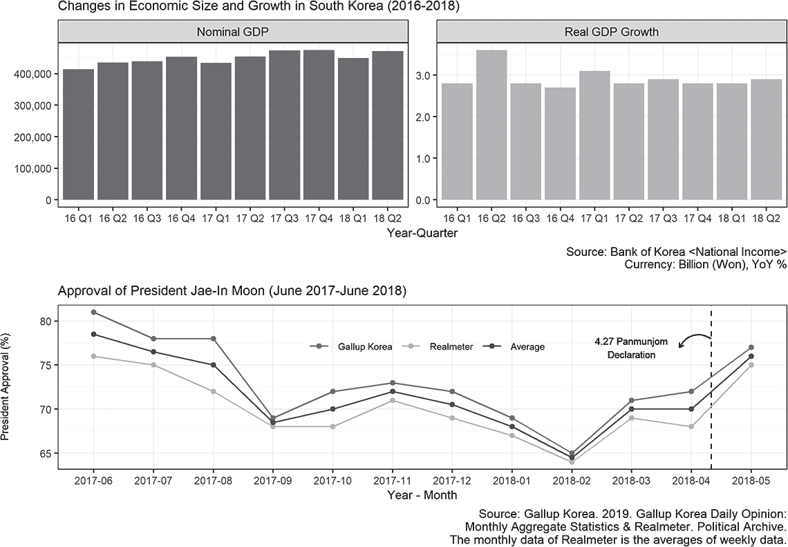

**Figure 1. Political and Economic Situation in South Korea (2017-2018)**

In 2017, North Korea continued the military provocation with a political slogan that promises the construction of great power. South Korea then announced a pledge to appease North Korea in the process of holding a presidential election on May 9, but North Korea neglected it. Jong-Un Kim's regime continued to provoke military tensions in South Korea, as well as in the United States and Japan. In 2018, starting from the

Pyeongchang Winter Olympics, the atmosphere of reconciliation between the two Koreas was created, and there was no North Korean missile launch. Thus, North Korea expanded its military provocations from 2015 to 2017, and by 2018 it showed signs of easing the tensions. In other words, the people of South Korea were exposed to the threat of North Korea's provocation until April 27, 2018, when the Panmunjom Declaration was announced. In sum, Figure 1 and North Korea's military provocation log show that it is difficult to observe the kind of macroscopic changes that can cause rapid changes in the attitudes toward North Korea and the unification of South Koreans, before and after the Panmunjom Declaration.

On the contrary, the lower panel of Figure 2 implies that the Panmunjom Declaration may have a critical influence on the South Koreans. It shows the monthly approval ratings of the presidential administration conducted by Gallup Korea and Realmeter. According to the lower panel, President Jae-In Moon's approval rates continued to decline, beginning in June 2016, and began sharply rebounding in February 2018. In February 2018, President Jae-In Moon and Yeo-Jung Kim, the vice director of the Central Committee of the Workers' Party of North Korea, had a meeting. Yeo-Jung Kim delivered a letter from Jong-Un Kim, chairman of the State Council, and verbally asked President Jae-In Moon to visit Pyongyang. This shows that the Panmunjom Declaration can be an influential event on the attitudes toward North Korea and unification compared to other events. Therefore, we will take a look at the discriminatory results from previous studies that appeared through public surveys after the Panmunjom Declaration in the context of the impact of political events.

1. Data

The data used in this paper is the Korean Broadcasting System (KBS) National Unification Consciousness Survey of 2018 conducted by KBS (hereafter, KBS survey). KBS surveyed for five days from August 3 to August 7, 2018. It weighted population proportions by gender, age, and region based on the registered population in July 2018. It is made up of 1,000 samples, valid for men and women over the age of 19 who live in cities and provinces. The KBS survey contains questions on the attitude toward North Korea in terms of leadership and general perception and attitudes toward unification after the Panmunjom Declaration. Also, it shows the least time difference from the

Panmunjom Declaration. Therefore, among the available survey data, it is the most suitable for use in the empirical analysis for this study.

It should be noted that this is not panel data that surveys the same respondents at different times. It is difficult to find significant events that could affect the attitude toward North Korea and unification at that time except for the Panmunjom Declaration. However, it does not mean that we can interpret that the change after the Panmunjom Declaration is due to the effect of the political event. It is necessary to consider that there are no available panel surveys to analyze the Panmunjom Declaration before-and-after. Hence, the KBS survey can be helpful for an empirical analysis of the individual level of attitudes toward North Korea and unification after the event, although the data have several limitations. If we are not overconfident of the results of the analysis, we can expect to find significant implications that will help us understand the changing attitudes of South Koreans toward North Korea and unification after the Panmunjom Declaration.

# Dependent Variables

1. Attitudes toward North Korea: Leadership, and General State

The dependent variables of interest are the attitudes toward North Korea, and unification. We use two questions to classify the attitude toward North Korea—North Korean leadership, or North Korea in general. We expect attitudes toward North Korea to be differentiated into North Korean leadership and North Korea as a general state. First, we look at the question about North Korean leadership: "What do you think of Jong-Un Kim's North Korean regime and its ruling leadership group?" The responses on North Korean leadership were given on a five-points scale, with 1 meaning "very dissatisfied" to 5, meaning "very satisfied." Also, we asked the question, "What do you think about North Korea?" to measure general attitudes toward North Korea. The responses are also measured on a five-point scale from 1, "I think North Korea is a hostile entity," to 5, "I think South Korea should support North Korea."

1. Attitudes toward Unification

We asked, "What do you think about unification?" Responses were measured on a four-point scale. The most frequent response is the opinion that respondents prefer unification if it creates no burdens (45.5%). Only 8.9% of respondents say that they do not prefer unification. A quarter of the respondents answer that they prefer the status quo (25.2%), and only 20.4% say they prefer unification unconditionally.

**Figure 2. Distributions of Dependent Variables**

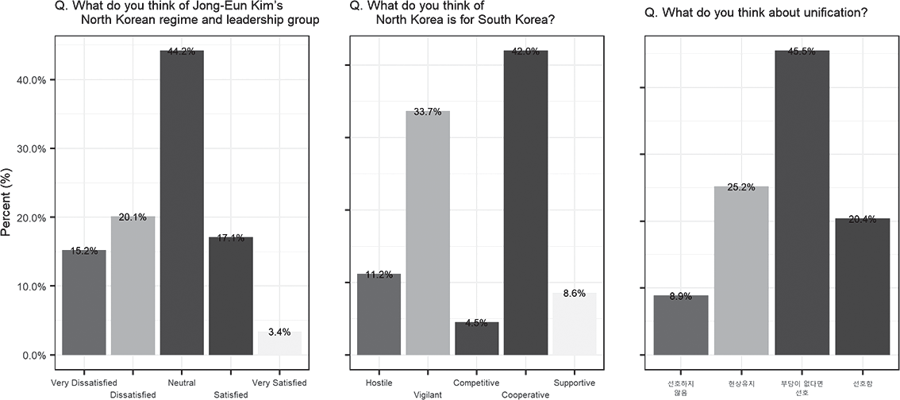

# Explanatory Variables

One of the main explanatory variables in this study is generational. We investigate how the generations are associated with the attitudes toward North Korea and unification after the Panmunjom Declaration. Generations are categorical variables measured in 10- year units based on age. The younger generations, in their 20s and 30s, are those who experienced several provocations of North Korea and the failure of appeasement policies. It means that the Panmunjom Declaration may not be an event critical enough to change their political attitude fundamentally. Instead, the younger generation can accept the Panmunjom Declaration as part of the repetitive North Korean warfare tactics.

Thus, we expect that the younger generations would persist in conservative views on North Korea regardless of its leadership and general perception. However, the older generations, in their 40s and 50s, who experienced the period of successful appeasement policies, would expect that the Panmunjom Declaration will bring peace again. Lastly, the oldest generation surveyed, those in their 60s and over, is expected to show a negative attitude toward the leadership, but not as a general perception. Since the oldest generation are those who experienced the Korean War or its immediate aftermath, for them, North Korea is both an enemy of the Korean War and, at the same time, belongs to the same Korean nationality. Therefore, unlike the previous studies, we expect a nonlinear relationship between different generations and attitudes toward North Korean leadership. Conversely, the relationship between generations and attitudes toward North Korea in general would not be distinctive across the generations since South Koreans have learned through a series of events that the people who are ruled in North Korea do not influence the inter-Korean relationship. The reference category among the generations are those in their 20s, who are expected, in this survey, to show conservative or negative attitudes toward North Korea even after the Panmunjom Declaration.

The other explanatory variable of interest is the prospect of unification. This variable consists of responses to the question, "When do you think unification will happen?" The longer the period of unification, the more negative the prospect. It is because we can view the negative responses for the expected unification period as a kind of "time of hesitation" that expects a transitional period, such as the preparation period for unification, considering the burdens, costs, and social problems that will arise from unification. Moreover, responses that the time when unification is possible is "near" or "impossible for the long term" means that the motivation and expectations for unification are low (Jeong, 2013, 82).

Finally, we control for other variables that can potentially affect the attitudes toward North Korea and unification. The variables include the regions where respondents live, gender, education level, income level, evaluations of North Korea policies under the Jae-In Moon administration, all drawn from the KBS survey data. Conventional wisdom asserts that regionalism has driven the outcomes of elections in the post-democratization period in Korea (Kim et al., 2008). We have observed a regional divide in which the electorate of the Youngnam and the Honam regions were opposed.

Even the Youngnam region is divided into two parts: northern Youngnam, with the city of Daegu, and southern Youngnam, with the cities of Pusan and Ulsan (Kang, 2000; Kim, 2010; Yoon, 2012).

Evaluations toward North Korea's policies under the Jae-In Moon administration is a proxy variable of political ideology or party identification, considered in previous studies. Political ideology mostly measures the spectrum of liberal or conservative, and party identification measures a respondent's attachment to a particular party as a primary political variable. The political ideology or party identification in current studies is used to explore the determinants of attitudes toward North Korea and unification. However, the KBS survey data used in this study do not include questions that directly measure the political ideology or party identification of respondents. We expect that the evaluations will show the ideological tendency because voters in South Korea have shown significant differences in policy issues in terms of North Korea support and the ROK-US alliance (Park et al., 2012). Socio-demographic variables, such as gender, education level, and income level, are also included.

# Empirical Findings

The dependent variables are the attitudes toward North Korea and unification, measured on a major five-point scale. Also, the variables have a discrete, not continuous, ranking. Therefore, we use ordered logistic regression to estimate the relationship between dependent variables and explanatory variables. The results of ordered logistic regression are natural logarithms of the odds ratio that show the probability of selecting each category of the dependent variable. Although coefficients of ordered logistic regression are in linear forms, it implies the nonlinear relationship between explanatory variables and the dependent variable. Hence, it is difficult to derive a direct implication through the coefficients. In this study, we show some of our results with predicted probabilities.

1. Attitudes toward North Korea after the Panmunjom Declaration

Table 1 is the result of examining the determinants of North Korea's perception through ordered logistic regression analysis for respondents after the Panmunjom

Declaration. In Model 1, respondents of all generations except those in their 30s were more likely to show more positive attitudes toward North Korean leadership compared to those in their 20s when we hold other explanatory variables constant. In other words, we can understand that the 20s and 30s are more likely to show negative attitudes and antipathy toward the North Korean leadership than other generations. Model 2 analyzes the determinants of North Korea in general. We cannot find any significant differences among generations compared to those in their 60s and older in terms of attitudes toward North Korea in general in Model 2. Although we changed the reference category from people in their 20s to those over 60, we cannot find statistically significant differences across the generations in terms of the attitudes toward North Korea in general.

**Table 1. Ordered Logistic Regression: Attitudes toward North Korea after the Panmunjom Declaration**

|  |  |  |
| --- | --- | --- |
|  | Attitudes toward North Korea | |
| Leadership | General |
| Generation: 30s | 0.313 (0.203) | -0.041 (0.206) |
| Generation: 40s | 0.521** (0.201) | 0.133 (0.203) |
| Generation: 50s | 0.574** (0.208) | -0.110 (0.206) |
| Generation: 60+ | 0.403 (0.209) | -0.182 (0.209) |
| NK policy Eval. | 1.427*** (0.085) | 1.219*** (0.082) |
| Region: Honam | -0.196 (0.206) | 0.073 (0.201) |
| Region: PK | -0.049 (0.167) | 0.095 (0.172) |
| Region: TK | -0.086 (0.204) | -0.285 (0.204) |
| Socio-demographic: Gender | 0.595*** (0.122) | 0.386** (0.121) |
| Socio-demographic: Education | -0.266* (0.122) | 0.032 (0.123) |
| Socio-demographic: Income | 0.174** (0.054) | 0.170** (0.055) |
| cut1 | 2.594*** (0.451) | 1.911*** (0.444) |
| cut2 | 4.071*** (0.462) | 4.319*** (0.464) |
| cut3 | 6.557*** (0.489) | 4.558*** (0.467) |
| cut4 | 8.785*** (0.524) | 7.307*** (0.497) |
| Log-likelihood ratio | 386.212 | 311.067 |
| Observations | 996 | 996 |

Note: *p < 0.05 **p < 0.01 ***p<0.001. Standard errors in parentheses. PK/TK are abbreviations of the regions: PK: Pusan/Ulsan/Kyeongnam TK:Taegu/Kyeongbuk.

1. Attitudes toward Unification after the Panmunjom Declaration

Table 2 examines the competing hypotheses about attitudes toward unification from previous studies, and the second hypothesis, that the prospects of unification affect the attitudes toward unification differently across generations. In particular, we break down the second hypothesis into two statements. First, the more positive the prospects for unification, the more likely it is that older generations will prefer unification. Secondly, the younger generations will not change their attitudes toward unification even they have a positive outlook on unification, since they have experienced the failure of appeasement policies and repeated North Korean provocation.

Model 3 is a basic model composed of variables that can influence attitudes toward unification derived from previous studies. Model 3 includes demographic variables, as well as variables that indicate the degree of interest in unification, and evaluation of the current government's policy toward North Korea policy. Respondents showed that the higher the interest in unification, the more they prefer unification. Likewise, the more supportive the current government's policy is toward North Korea, the more likely people will respond that they prefer unification. Model 4 shows the influence of generations on attitudes toward unification. Since the reference group is people in their 20s, we can interpret the results as effects of generations in comparison with those in their 20s on attitudes toward unification after the Panmunjom Declaration. Unlike previous studies, all generations did not show statistically significant differences from people in their 20s. Previous studies point out that the younger generations, such as those in their 20s and 30s, tend to prefer unification less, since the generations are more likely to approach unification issues with a view to utility maximization rather than historical nationalism, and will feel that unification is not practical (Cho and Han, 2014). However, after the Panmunjom Declaration, the generations do not show statistical differences between each other, which are contrary to previous studies.

Model 5 analyzes the relationship between the prospect for and the attitudes toward the unification. The longer the expected period of unification is, the more negative the prospect is, because we can consider it a transitional period. In other words, the expected period for unification is not only the preparation period for unification, but also the time of hesitation when we take into account the burdens, costs, and social issues that will arise from unification. Moreover, the response that the time when unification is

**Table 2. Ordered Logistic Regressions: Attitudes toward North Korea after the Panmunjom Declaration**

|  |  |  |  |  |
| --- | --- | --- | --- | --- |
|  | Base | Generation | Prospects | Full |
| Generation: 30s |  | 0.137 (0.209) |  | 1.239* (0.619) |
| Generation: 40s |  | 0.057 (0.206) |  | -0.118 (0.633) |
| Generation: 50s |  | 0.304 (0.211) |  | 1.971** (0.604) |
| Generation: 60+ |  | 0.307 (0.217) |  | 1.787*** (0.535) |
| Prospects of unification |  |  | 0.421*** (0.049) | 0.693*** (0.117) |
| 30s × Prospects |  |  |  | -0.284 (0.158) |
| 40s × Prospects |  |  |  | 0.033 (0.158) |
| 50s × Prospects |  |  |  | -0.443** (0.149) |
| 60+ × Prospects |  |  |  | -0.375** (0.134) |
| Interests of unification | 1.247*** (0.092) | 1.230*** (0.093) | 1.085*** (0.094) | 1.090*** (0.095) |
| NK policy Eval. | 0.657*** (0.081) | 0.672*** (0.083) | 0.498*** (0.084) | 0.515*** (0.086) |
| Region: Honam | -0.220  (0.212) | -0.232 (0.211) | -0.156  (0.215) | -0.188 (0.215) |
| Region: PK | -0.044  (0.172) | -0.046 (0.172) | -0.017  (0.173) | -0.023 (0.175) |
| Region: TK | 0.049  (0.205) | 0.039 (0.205) | 0.140  (0.207) | 0.103 (0.209) |
| Socio-demographic: Gender | -0.144  (0.123) | -0.151 (0.123) | -0.252* (0.125) | -0.291* (0.126) |
| Socio-demographic: Education | -0.013  (0.111) | 0.064 (0.123) | -0.028  (0.113) | 0.065 (0.125) |
| Socio-demographic: Income | -0.044  (0.054) | -0.041 (0.055) | -0.080  (0.055) | -0.071 (0.056) |
| cut1 | 2.404*** (0.405) | 2.777*** (0.474) | 2.636*** (0.412) | 4.109*** (0.617) |
| cut2 | 4.543*** (0.422) | 4.914*** (0.488) | 4.916*** (0.433) | 6.435*** (0.638) |
| cut3 | 7.123*** (0.455) | 7.504*** (0.52) | 7.625*** (0.47) | 9.187*** (0.669) |
| Log-likelihood ratio | 377.507 | 380.96 | 455.642 | 479.648 |
| Observations | 996 | 996 | 996 | 996 |
| Note: * p<0.05; **p<0.01; *** p<0.001. Standard errors in parentheses. PK/TK are abbreviations of the regions: PK: Pusan/Ulsan/ Kyeongnam, TK:Taegu/Kyeongbuk. |  |  |  |  |

possible is near or impossible for the long term means that motivation and expectations for unification are low (Jeong, 2013, 82). In Model 5, respondents display negative attitudes toward unification as they are more cynical about the prospect for unification, which was statistically significant.

Lastly, we constructed Model 6 to test the second research hypothesis. When the Panmunjom Declaration brings about fundamental changes in recognition of unification by respondents, we expect that the more positive the prospects for unification are, the more likely the generations who have experienced past cooperative events will show positive attitudes toward unification. Alternatively, respondents may accept the

**Figure 3. Changes in Predicted Probabilities by Generation on Attitudes toward Unification**

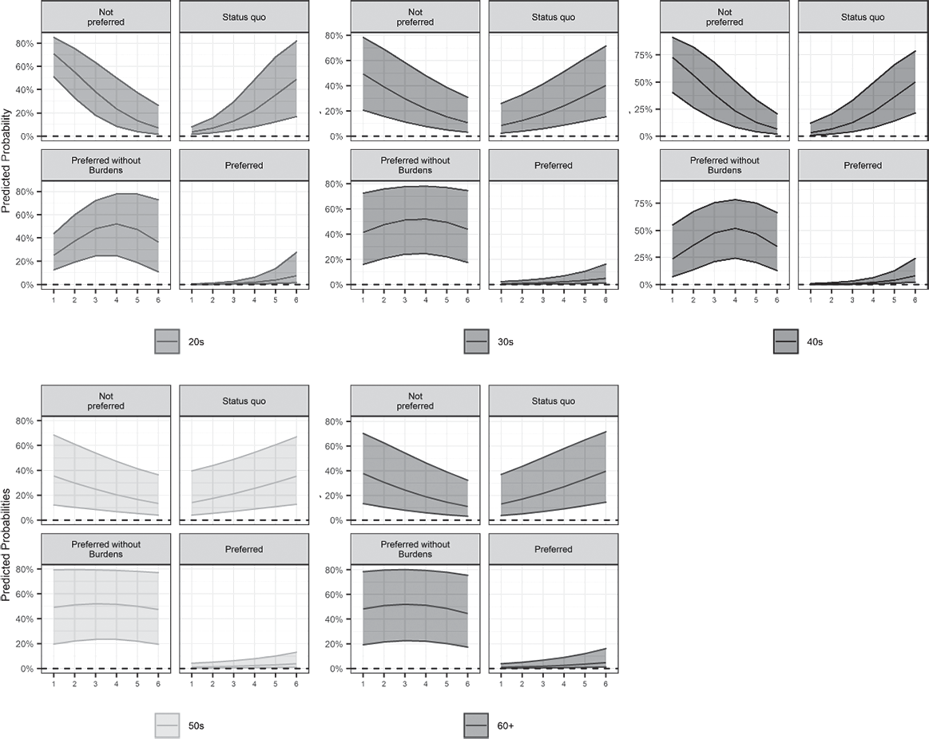

**without Burdens**

**Preferred**

**without Burdens**

**Preferred**

**Preferred**

**Preferred**

**Preferred**

**Preferred**

**without Burdens**

**Status quo**

**Not preferred**

**Status quo**

**Not preferred**

**Preferred**

**Preferred**

**without Burdens**

**Preferred**

**Preferred**

**without Burdens**

**Status quo**

**Not preferred**

**Status quo**

**Not preferred**

**Status quo**

**Not preferred**

Panmunjom Declaration as a part of North Korea's stick-and-carrot strategy, not as a substantial change in the benefits and costs of unification. We examine the interactions between the two variables on the dependent variable by changing the prospects for unification by the predicted probability in Figure 3.

Although Model 6 presents that the 50s and 60s are statistically different from the 20s, Figure 3 show the details, which we need to think about their implications. When the prospects become positive, all generations show similar patterns that they are more likely to prefer unification, and less likely to oppose to it. However, the 50s and 60s are different in terms of the answers of "preferred without burdens," and "Status-quo." The 50s and 60s do not show much variations by varying prospects of unification, while the 20s, 30s and the 40s show greater variations as the prospects become positive when they answer "preferred without burdens." With the answer of "Status quo," all the generations are more likely to hold the status-quo as the prospects of unification become positive, but the younger generations (20s, 30s and 40s) show greater increasing rates. It implies that the younger generations are also sensitive to the prospects of unification when they judge the inter-Korean relationships.

# Conclusion and Implications

This study investigates the attitudes toward North Korea and unification based on data from the KBS National Unification Consciousness Survey of 2018. From the data, the generations who feel the most opposition to North Korean leadership appear to be people in their 20s and 30s. However, people in their 20s perceive North Korea in general to be relatively moderate. It tells us that people in their 20s have the most substantial attitudinal gap between the leadership and their perception of North Korea in general.

The generational change also appears in the analysis of attitudes toward unification after the Panmunjom Declaration. Variables such as the degree of interest in unification, and the evaluation of current governmental North Korea politics, are consistently related to the attitude toward unification, but generational variables have different impacts on unification preferences across the generations. For instance, people in their 30s, 50s, and 60s and above are more likely to prefer unification conditional on increasing positive

prospects of unification compared to people in their 20s. In other words, people in their 20s became the generation that least prefers unification across the generations. However, when we compared people in their 20s to people in their 40s in Table 4, it shows that the tendencies of both are similar in changes of predicted probabilities. It implies that the 20s are the generation that shows the most negative attitudes toward North Korea leadership and unification; their attitudes are not static, but conditional to the external environment, such as the change in inter-Korean relationships.

We focus on the effect of the Panmunjom Declaration and attempt to verify whether it had a positive effect on the prospects for future unification like the previous inter-Korean cooperation cases. If respondents from all generations improved in their attitude toward unification as the unification prospects change after the Panmunjom Declaration, we could expect that the declaration is the event that has brought about a significant change in unification. However, it is difficult to say that the event improves the prospects of unification (Figure 10 and Figure 11), and people in their 20s show consistent negative attitudes toward North Korean leadership and unification. In terms of unification, in particular, even when the prospects of unification increase, people in their 20s are more likely to have the most negative attitudes toward unification on average. In particular, the younger generations and the 40s seem to estimate the costs and benefits by the extent to the expected unification timing.

The changes, which are difficult to find in previous studies, clearly show that the generation of our society is changing its attitude toward North Korea and unification issues. Generational changes have been observed as fragmentary events since 2017. For example, the strong antipathy from people in their 20s and 30s over the 2018 Pyeongchang Winter Olympics over the formation of the single inter-Korean women's ice hockey team was challenging to find before that. Similarly, this paper also consistently showed a negative attitude toward North Korea and unification from the younger generation, which can be said to capture the facets of generational changes in our society. The results of this study show that the significant events driving changes in inter- Korean relations can be made on the supply side, but we should also pay attention to the changes that appear in the ordinary people, who are the consumers, and other parties of the inter-Korean relationship. The changes after the Panmunjom Declaration suggest that the people who experience essential events in the inter-Korean relationship form

significantly different attitudes or prospects for North Korea and unification. Thus, the government, as a supplier in the unification and North Korea issues, not only provides one-sided policy options but should also embrace the people's perceptions and attitudes, which are sensitive to changes in the real world. At the same time, to establish the justification logic of unification based on generational changes, it is necessary to ensure long-term consistency in at least unification and North Korea policy. Without policy consistency, citizens cannot set the expected costs and benefits of unification to their standards, which will make people anxious because of the uncertainty of inter-Korean relations.

Lastly, we should note that the Panmunjom Declaration is a prominent political event, but we do not need to overestimate it. The agreement between the Panmunjom Declaration and the September 19 Pyongyang Joint Declaration made significant progresses in many areas. However, the two Koreas seem at a standstill, as the second North American summit in Hanoi in February 2019 concluded without much success. Although South Korea has long held political discussions related to North Korea and unification since the division, we could not solve the fundamental problem. Political leaders should consider public opinion to secure the driving force for solving unification and North Korea problems. In particular, in order to fundamentally change the perception toward North Korea and unification, a domestic effort to supplement it is urgently needed—not a one-off event.

References

Abramowitz A (2008). "Forecasting the 2008 Presidential Election with the Time-for-Change Model." *PS: Political Science & Politics*, 41(4), 691–695.

Bae JS (2018). "Generation and Ideology Factors of Evaluation on North Korea and Security Policy." *Korean and World Politics*, 34(2), 99–135.

Bartels LM (2000). "Partisanship and Voting Behavior, 1952-1996." *American Journal of Political Science*, 44(1), 35-50.

Campbell A, Converse PE, Miller WE, Stokes DE (1960). *The American Voter*. Riley, New York. Chang KY (2018). "Aging and Generational Effects on South Korean Attitudes toward North

Korea's Nuclear Threat." Journal of Future Politics, 8(2), 33–57.

Cho JH (2018). "North Korea leader Kim Jong Un scores surprising favorability among South Koreans after summit: Poll finds 78 percent of S. Koreans responded positively to his trustworthiness." URL https://abcnews.go.com/International/north-korea-leader-kim- jong-scores-surprising-favorability/story?id=54933996.

Cho JM, Han JT (2014). "A Comparative Analysis on the Perceptional Differences of the Younger Generations between South and North Korea regarding the Reunification Issues." *Journal of East and West Studies*, 26(1), 149–178.

Choi JY (2016). "Differentiated Perceptions of the Benefits and the Necessity of Korean Reunification." *National Strategy*, 22(3), 113–138.

Fiorina MP (1981). *Retrospective Voting in American National Elections*. Yale University Press, New Haven.

Healy AJ, Malhotra N, Mo CH (2010). "Irrelevant events affect voters' evaluations of government performance." Proceedings of the National Academy of Sciences of the United States of America, 107(29), 107 (29) 12804-12809; DOI: 10.1073/pnas.1007420107.

Hur SJ (2014). "Generation Replacement and Changing Perception on North Korea: Cohort Analysis." *Peace Studies*, 22(2), 73–112.

Jang Sj (2013). "Economic Democratization and the 18th Presidential Election: Issue Voting and Political Knowledge." *Korean Party Studies Review*, 12(1), 87–112.

Jeong EM (2013). "The Changes of Attitude toward Reunification between North and South Koreans: Focusing on Analysis of the Surveys, 2011˜2013." *Journal of Peace and Unification Studies*, 5(2), 74–104.

Jung DJ (2016). "South Korean Citizens' Attitudes toward Unification after the 2016 National Assembly Election: Ideological Polarization or Partisan Bias?" *Korean Political Science Review*, 50(5), 131–161.

Kang WT (2000). "Regionalist Voting and Rational Choice: A Critical Review." *Korean Political Science Review*, 34(2), 51–67.

Kim H, Choi JY, Cho J (2008). "Changing cleavage structure in new democracies: An empirical analysis of political cleavages in Korea." *Electoral Studies*, 27(1), 136–150.

Kim Jh (2010). "The Change of Korean Regionalism: A View on Voting Behaviors and Political Parties." *Journal of Contemporary Politics*, 3(2), 89–114.

Kim P (2017). "Effects of Inter-Korean Events on the Conception of Unification." *Journal of peace and unification*, 9(2), 157–184.

Kim S (2018). "Summit in 2000 made history with big hopes." URL: https: //koreajoongangdaily. joins.com/news/article/article.aspx?aid=3047405.

Kim TH, Namkung G, Yang YS (2003). "Korean People's Foreign Policy Beliefs and National Images of North Korea." *Korean Political Science Review*, 37(3), 151–174.

Kim YT (2007). "The 2007 Presidential Election and Effects of "North Korean Variables"." *The Journal of Political Science & Communication*, 10(2), 65–77.

Klar S (2014). "Partisanship in a social setting." *American Journal of Political Science*, 58(3), 687– 704.

Lee JC (2008). "Economic Voting in the 17th Presidential Election: Economic Perception and Voting Behavior." *Journal of Contemporary Politics*, 1(1), 111–136.

Lee SS (2013). "Do We Trust North Korea?: An Analysis of Korea Trust Process with Survey Data."

*Korean Political Science Review*, 47(4), 113–133.

Lim J, Seo H (2009). "Frame flow between government and the news media and its effects on the public: Framing of North Korea." *International Journal of Public Opinion Research*, 21(2), 204–223.

Luskin RC (1987). "Measuring Political Sophistication." *American Journal of Political Science*, 31(4), 856–99.

Moon WJ (2018). "Economic Voting, Electoral Punishment, and Democracy: The Effects of Objective and Subjective Economic Evaluations on the Support of Incumbent Party Candidates." *Peace Studies*, 26(2), 5–44.

Oh J (2018). "Moon's approval rating surges after inter-Korean summit." URL [https://www.upi.com/](http://www.upi.com/Top)Top{_}News/World-News/2018/05/07/Moons-approval- rating-surges-after-inter-Korean-summit/5181525665543/.

Park KM, Han JT, Lee JH (2012). "The Constructive Characteristics of Ideological Conflicts in South Korea." *Korean Party Studies Review*, 11(3), 127–154.

Rahn WM (1993). "The Role of Partisan Stereotypes in Information Processing About Political Candidates." *American Journal of Political Science*, 37(2), 472–96.

Ryu Js (2012). "The Roles of Political Knowledge through Political Ideology in Formation of Policy Preferences." *Journal of Korean Political Science Reviews*, 21(2), 53–86.

Seong Yc, Hong Sj (2018). "President Moon's approval rating drops below 60% for first time since inauguration." URL [http://english.hani.co.kr/arti/english{_}edition/e{_}national/829656.](http://english.hani.co.kr/arti/english) html.

Smith G (2005). "Politically Significant Events and Their Effect on the Image of Political Parties."

*Journal of Political Marketing*, 4(2-3), 91–114.

Smith J, Kim C (2018). "From nuclear weapons to peace: Inside the Korean summit declaration." URL [https://www](http://www/). reuters.com/article/us-northkorea-southkorea-declaration-exp/from- nuclear-weapons-to-peace-inside-the-korean-summit-declaration-idUSKBN1HY1ZY.

Song YH, Kwon SH (2013). "Determinants of Individuals' North Korea Policy Preferences: Survey Evidence for Roh Moo-hyun and Lee Myung-bak Administrations." *The Journal of Asiatic Studies*, 56(1), 153–182.

Yoon Ki (2012). "Regionalism and the 19th National Election." *Korean Journal of Political Science*, 20(2), 113–138.